Guaranteed Interview Scheme
We guarantee to interview anyone with a disability whose application meets the minimum criteria for the post.
By ‘minimum criteria’ we mean that you must provide us with evidence in your application form which demonstrates that you generally meet the level of competence required for each competence, as well as meeting any of the qualifications, skills or experience defined as essential. The Cabinet Office is committed to the employment and career development of disabled people (the minimum criteria means the essential competences as set out in the advertisement for the post).
What do we mean by disability?
The Disability Discrimination Act, 1995 defines a disabled person as someone who has a physical or mental impairment which has a substantial and adverse long-term effect on his or her ability to carry out normal day-to-day activities.
How do I apply?
If you want to apply for a guaranteed interview, simply complete the declaration below and send it in with your application.
We will try to provide access, equipment or other practical support to ensure that if you have a disability you can compete on equal terms with non-disabled people.
DECLARATION
Post applied for: General Manager, Islington Mill
I consider myself to have a disability as defined above and I would like to apply for a guaranteed interview.
I require the following special arrangements to be made for me to be able to attend an interview:
Name:  Signature: | Date:

Please return the completed form with your application
ANY FALSE DECLARATION OF DISABILITY TO OBTAIN AN INTERVIEW WILL SUBSEQUENTLY INVALIDATE ANY OFFER OF A POST
Data Protection Act, 1998
Information provided by you as part of your application will be used in the recruitment process only – data will be held securely with access restricted to those involved in the process. Once this process is complete, data relating to unsuccessful applicants will be stored for a max. of 12 months and then destroyed. If you are the successful candidate, your application will be retained and form the basis of your personal record.
Information provided by you in the Equal Opportunities form will be used to monitor Islington Mill’s diversity policies and practices. By submitting your completed application you are giving consent to your data being stored and processed for the purpose of the recruitment process, equal opportunities monitoring and your personal record if you are the successful candidate.
Thank you for your interest in working for Islington Mill.

Contact details

Islington Mill
1 James Street
Salford
Greater Manchester, M3 5HW

0161 278 6404

www.islingtonmill.com

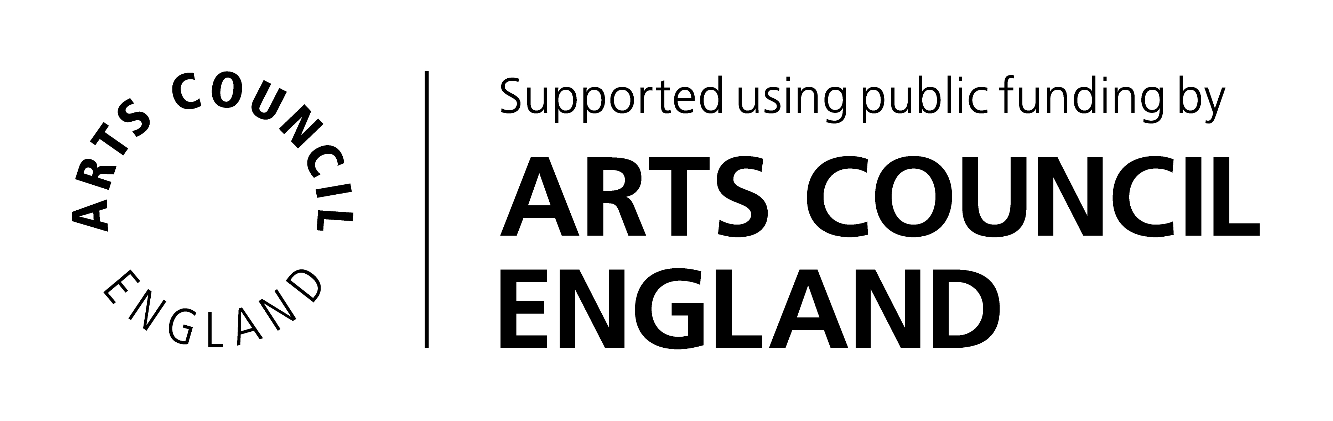
Islington Mill Arts Club, Registered in England (No 06668777)
Registered office Islington Mill, James Street, Salford, Greater Manchester, M3 5HW.

