Application Form: Projects Coordinator, Islington Mill
Please complete your application as fully as possible based on the information we have given you, with reference to the Projects Coordinator Job Description, and the person specification in particular. Please note that we will not refer to your CV for the purposes of shortlisting, so please ensure that everything you wish us to consider is within this application form.
Contact us if, for reasons of disability you wish to respond in an alternative format.
Please return your application form, CV and completed Equal Opportunities Monitoring Form by email info@islingtonmill.com The subject field of your email should read ‘Application: Projects Coordinator, Islington Mill’ followed by your name.
Alternatively, your completed application form, CV and Equal Opportunities Monitoring Form can be posted (marked CONFIDENTIAL) to:
Joanne Byrne
Islington Mill
1 James Street
Salford
Greater Manchester, M3 5HW

You will receive an acknowledgement of your application. If you are shortlisted we will email to invite you to attend interview with details of the time, location, interview panel and format, including whether you need to prepare anything in advance for the interview.
In some instances, we may ask shortlisted applicants for a second interview.

Personal details
Full name
Contact address
Home phone
Work phone (if we may use it)
Mobile phone
Contact email

Current or most recent employment (including self-employment)
Organisation
Job title
Date from (to)
Current or final salary
Notice period
Main responsibilities
Describe an outcome you are really proud of that you achieved in this role
Motivation for taking your next step

Work history
Please complete for two previous posts, and enclose a CV to cover your career to date
Organisation
Job title
Date from /to
Main responsibilities
Describe an outcome you are really proud of that you achieved in this role
Motivation for taking your next step

Organisation
Job title
Date from /to
Main responsibilities
Describe an outcome you are really proud of that you achieved in this role
Motivation for taking your next step
Educational and Alternative Learning Experience
Educational establishment / Alternative equivalent
Date from / to
Qualifications / Expertise obtained
Educational establishment / Alternative equivalent
Date from / to
Qualifications / Expertise obtained

Other training, professional qualifications or equivalent experience
Training body
Date from / to
Qualifications / Expertise obtained
Training body
Date from / to
Qualifications / Expertise obtained
Training body
Date from / to
Qualifications / Expertise obtained

Your experience in relation to the post
Please respond to the following questions: (in no more than 2 x sides of A4)
A/ What excites you about working with Islington Mill? What would you like to get from engaging with our communities and projects?
B/ Using the job description and specification as a guide, please outline how your experience and which of your skills align with the criteria for this post, providing specific examples drawn from your paid employment or voluntary work. We cultivate transparency and invite you to share honestly your current strengths and not-yet strengths. We do believe in learning on the job where there is the desire, and it is appropriate to do so.

References
Please give the names, addresses, telephone numbers and positions of two people to whom reference may be made. If you do not wish referees to be contacted before a provisional offer of employment please indicate. All appointments are subject to receipt of references that we find to be satisfactory. No offer of employment can be finalised until two references have been received.
Full name
Job title
Contact address
Contact phone
Contact email

May we approach at any time?
OR only after a conditional offer of employment has been made?

Full name
Job title
Contact address
Contact phone
Contact email

May we approach at any time?
OR only after a conditional offer of employment has been made?

In order to comply with the Immigration Act 1996 we are required to see proof of your right to work in the UK. This will be requested once an offer of employment has been made. If you require a work permit to work in the UK please indicate.
I require a work permit and can provide this.

Please give details of any criminal convictions you have had, excluding any ‘spent’ under the Rehabilitation of Offenders Act 1974 (minor motoring offences may be disregarded).
Declaration
By sending us your application by email or post you confirm all information given on this form is, to the best of your knowledge and belief, accurate and complete and that you have omitted nothing, which to the best of your knowledge might affect this application. You also agree the information included on this form may be used by Islington Mill for assessment of your application. If you prefer to send us your application by mail, please confirm the above by signing below.

Signature
Date

Thank you for your interest in working with Islington Mill.

Contact details
Islington Mill
1 James Street
Salford
Greater Manchester, M3 5HW

0161 278 6404

www.islingtonmill.com

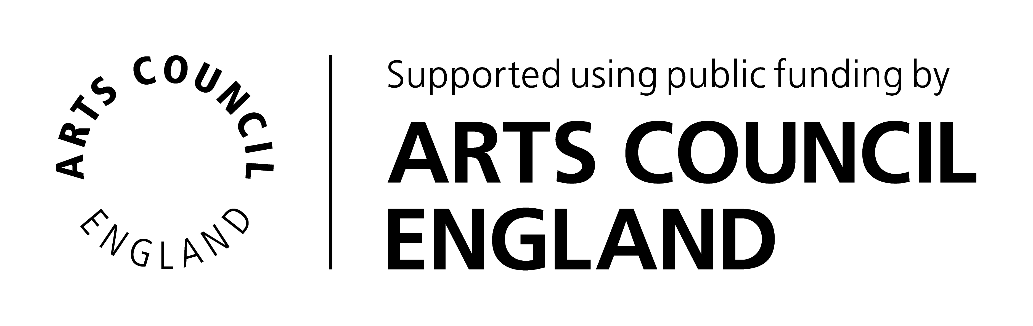
Islington Mill Arts Club, Registered in England (No 06668777)
Registered office Islington Mill, James Street, Salford, Greater Manchester, M3 5HW.

